Sales and Support Analysis

Fliipazon Retail is a multinational company that operates a chain of retail stores across different regions. They sell a wide range of products and want to analyse their sales data to gain insights into their business performance and make informed decisions. They have a relational database that stores the following data:

Segment 1: Database - Tables, Columns, Relationships
- Identify the tables in the database and their respective columns.

Tables in the database: 3 tables (agents, customer, orders)
Query:
SHOW TABLES;

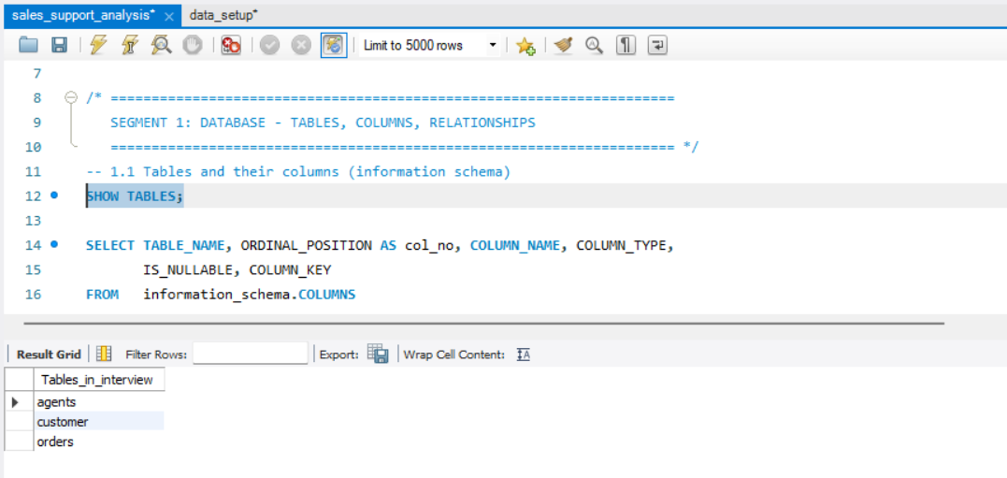
Output columns (in order): table_name, col_no, column_name, column_type, is_nullable, column_key
Row count: 25 (agents 6, customer 12, orders 7)
Concept used: information_schema, ORDER BY
Table used: information_schema.COLUMNS
Query:
SELECT TABLE_NAME, ORDINAL_POSITION AS col_no, COLUMN_NAME, COLUMN_TYPE, IS_NULLABLE, COLUMN_KEY
FROM information_schema.COLUMNS
WHERE TABLE_SCHEMA = 'interview'
ORDER BY TABLE_NAME, ORDINAL_POSITION;

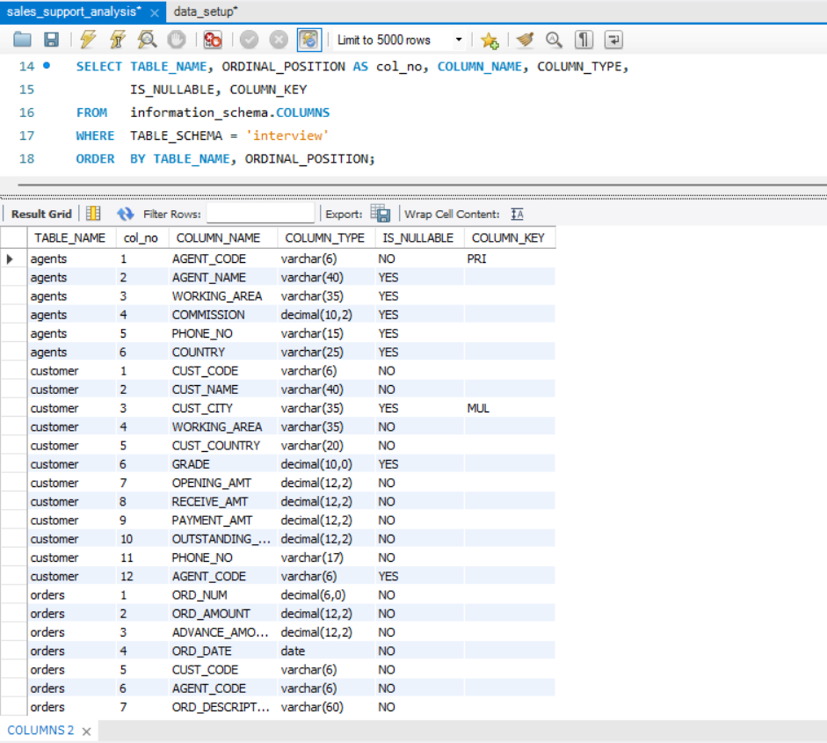
- Determine the number of records in each table within the schema.

Output columns (in order): table_name, row_count
Row count: 3 (12, 25, 36)
Concept used: COUNT(*), UNION ALL
Table used: agents, customer, orders
Query:
SELECT 'agents' as table_name, COUNT(*) AS row_count FROM agents
UNION ALL
SELECT 'customer' as table_name, COUNT(*) AS row_count FROM customer
UNION ALL
SELECT 'orders' as table_name, COUNT(*) AS row_count FROM orders;

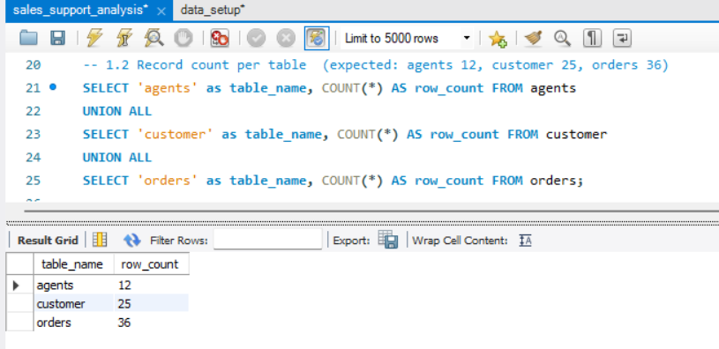

- Identify and handle any missing or inconsistent values in the dataset.

Determing the character length of the data in each columns for all the tables so that to analyse the extra trailing spaces
Query:
SELECT agent_code, agent_name, working_area, phone_no, country,
CHAR_LENGTH(agent_code) AS code_len,
CHAR_LENGTH(agent_name) AS name_len,
CHAR_LENGTH(working_area) AS area_len,
CHAR_LENGTH(phone_no) AS phone_len,
CHAR_LENGTH(country) AS country_len
FROM agents;

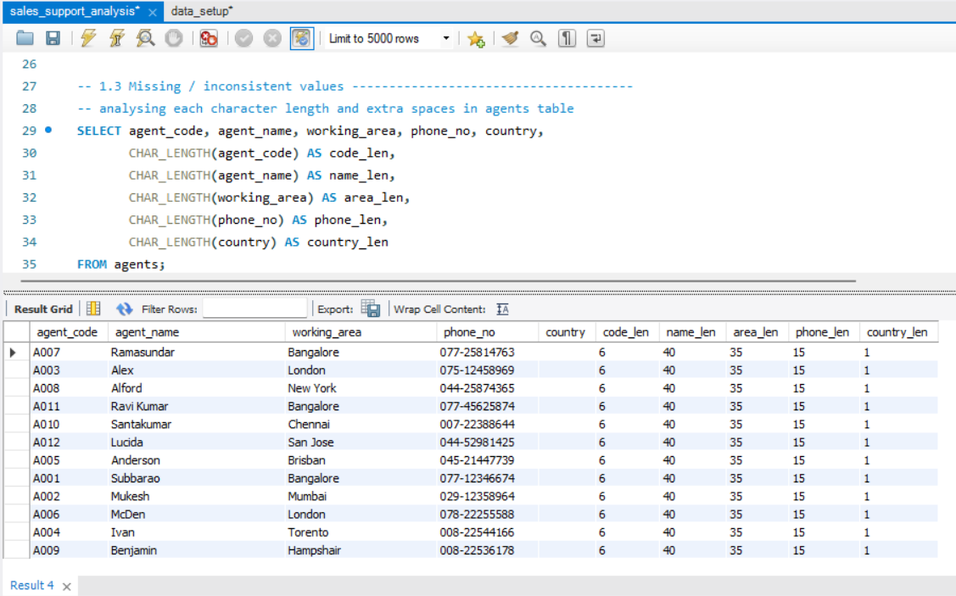
SELECT *,
CHAR_LENGTH(cust_code) AS code_len,
CHAR_LENGTH(cust_name) AS name_len,
CHAR_LENGTH(cust_city) AS city_len,
CHAR_LENGTH(working_area) AS area_len,
CHAR_LENGTH(cust_country) AS country_len,
CHAR_LENGTH(grade) AS grade_len,
CHAR_LENGTH(opening_amt) AS opening_amt_len,
CHAR_LENGTH(receive_amt) AS receive_amt_len,
CHAR_LENGTH(payment_amt) AS payment_amt_len,
CHAR_LENGTH(outstanding_amt) AS outstanding_amt_len,
CHAR_LENGTH(phone_no) AS phone_len,
CHAR_LENGTH(agent_code) AS agent_code_len
FROM customer;

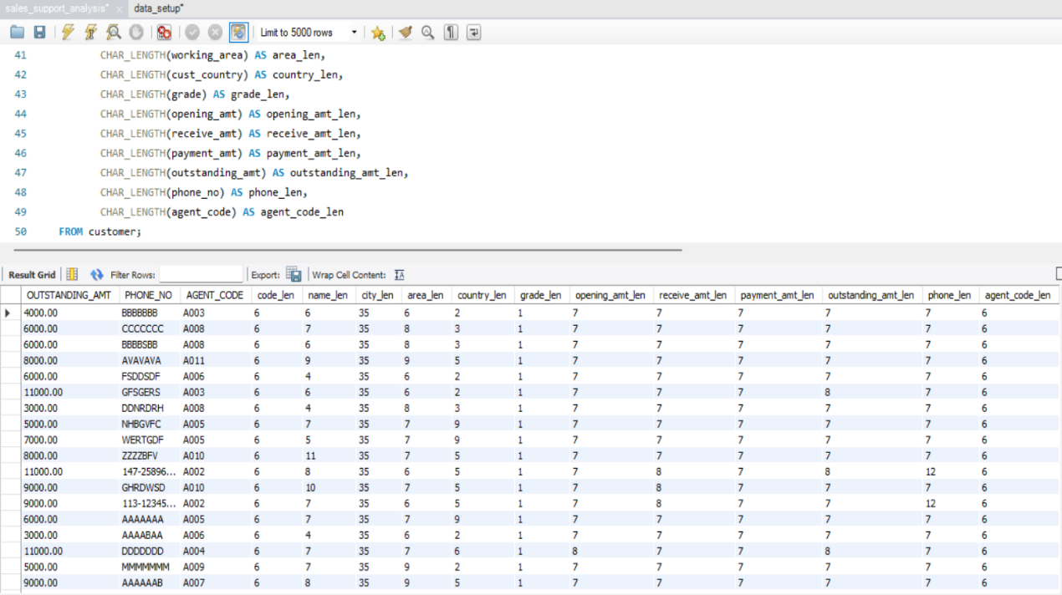

SELECT *,
CHAR_LENGTH(ord_num) AS ord_no_len,
CHAR_LENGTH(ord_amount) AS amt_len,
CHAR_LENGTH(advance_amount) AS adv_amt_len,
CHAR_LENGTH(ord_date) AS date_len,
CHAR_LENGTH(cust_code) AS cust_code_len,
CHAR_LENGTH(agent_code) AS agent_code_len,
CHAR_LENGTH(ord_description) AS description_len
FROM orders;

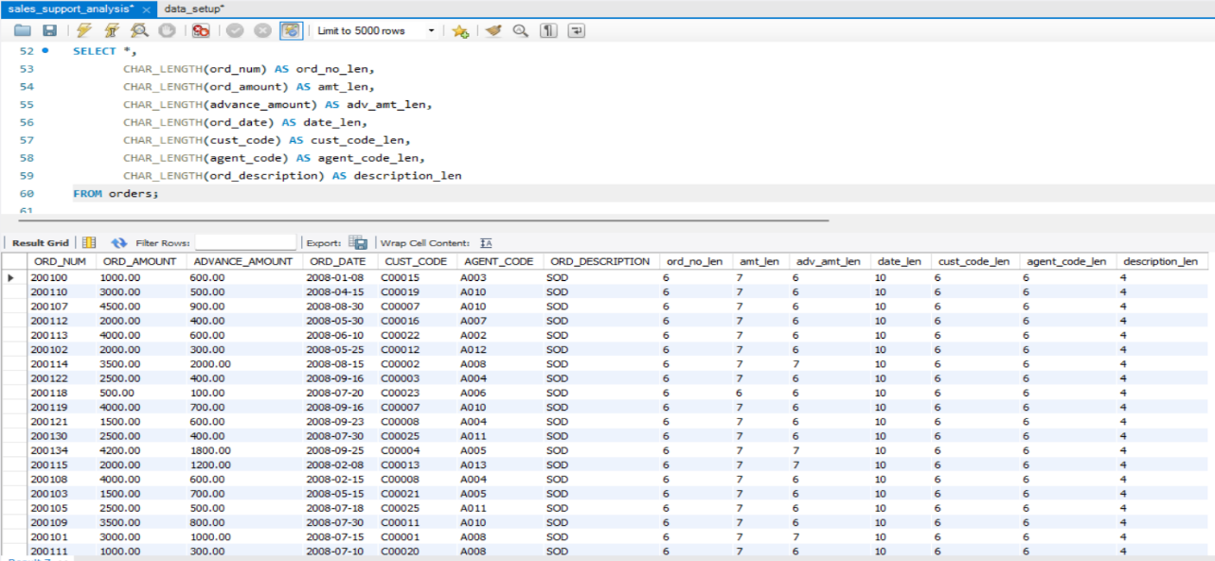
analysing all the padded spaces in agents, customer and orders table
SELECT
SUM(CHAR_LENGTH(agent_code) <> CHAR_LENGTH(TRIM(agent_code))) AS code_padded,
SUM(CHAR_LENGTH(agent_name) <> CHAR_LENGTH(TRIM(agent_name))) AS name_padded,
SUM(CHAR_LENGTH(working_area) <> CHAR_LENGTH(TRIM(working_area))) AS area_padded,
SUM(CHAR_LENGTH(phone_no) <> CHAR_LENGTH(TRIM(phone_no))) AS phone_padded
FROM agents;

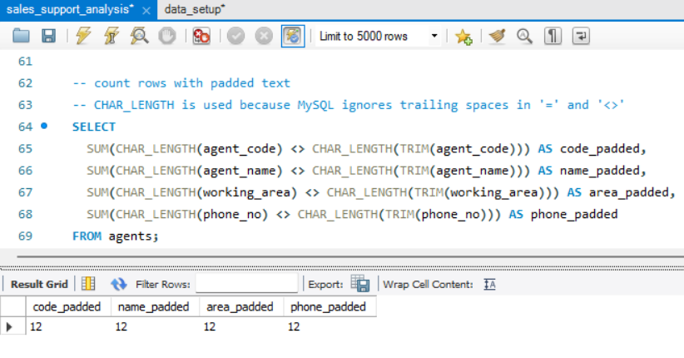
Output columns (in order): code_padded, name_padded, area_padded, phone_padded
Row count: 1 (12, 12, 12, 12)
Concept used: CHAR_LENGTH, TRIM, SUM of true/false
Table used: agents
For customer table
SELECT
SUM(CHAR_LENGTH(cust_code) <> CHAR_LENGTH(TRIM(cust_code))) AS code_padded,
SUM(CHAR_LENGTH(cust_name) <> CHAR_LENGTH(TRIM(cust_name))) AS name_padded,
SUM(CHAR_LENGTH(cust_city) <> CHAR_LENGTH(TRIM(cust_city))) AS city_padded,
SUM(CHAR_LENGTH(working_area) <> CHAR_LENGTH(TRIM(working_area))) AS area_padded,
SUM(CHAR_LENGTH(cust_country) <> CHAR_LENGTH(TRIM(cust_country))) AS cust_country_padded,
SUM(CHAR_LENGTH(phone_no) <> CHAR_LENGTH(TRIM(phone_no))) AS phone_no_padded,
SUM(CHAR_LENGTH(agent_code) <> CHAR_LENGTH(TRIM(agent_code))) AS agent_code_padded
FROM customer;

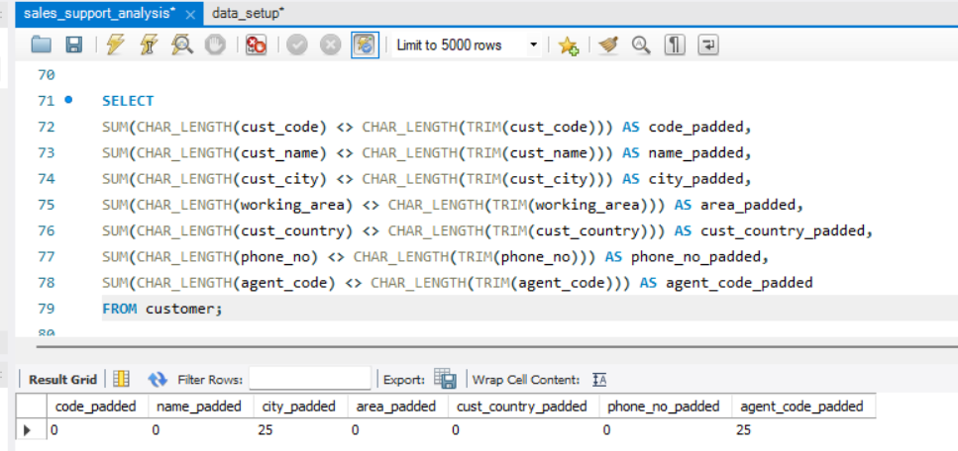

For orders table
SELECT
SUM(CHAR_LENGTH(cust_code) <> CHAR_LENGTH(TRIM(cust_code))) AS cust_code_padded,
SUM(CHAR_LENGTH(agent_code) <> CHAR_LENGTH(TRIM(agent_code))) AS agent_code_padded
FROM orders;

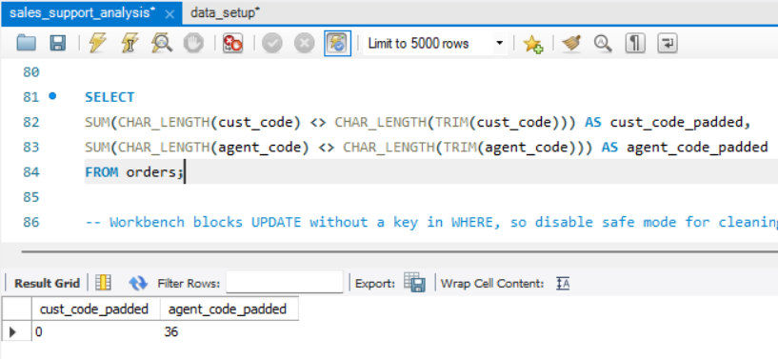

Trimming all the required data
Concept used: UPDATE, TRIM

UPDATE agents
SET agent_code = TRIM(agent_code),
agent_name = TRIM(agent_name),
working_area = TRIM(working_area),
phone_no = TRIM(phone_no);

UPDATE customer
SET cust_city = TRIM(cust_city),
agent_code = TRIM(agent_code);

UPDATE orders
SET agent_code = TRIM(agent_code);

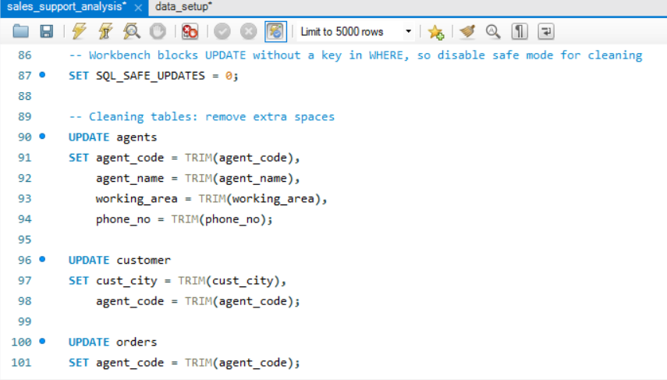

After trimming extra spaces from all the tables, the padding spaces become 0
Output:
For agents table
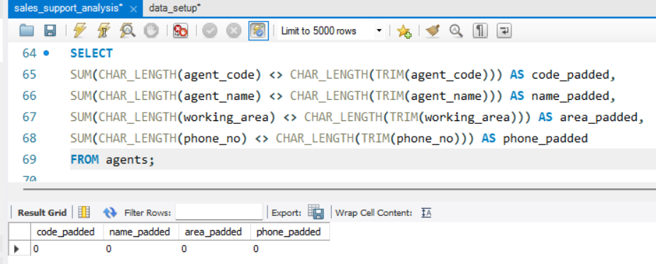

For customer table
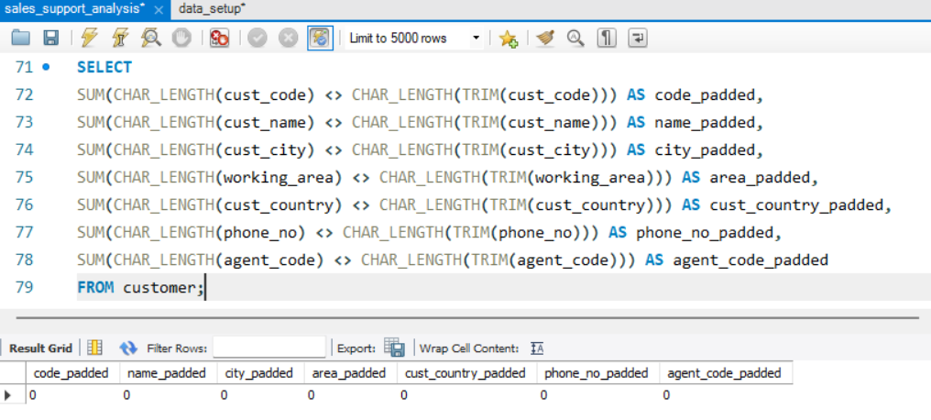

For orders table
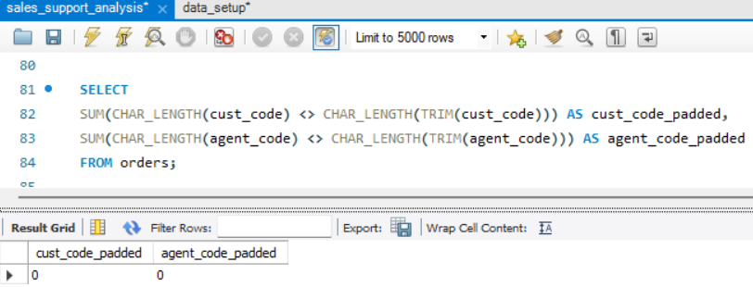

SELECT COUNT(*) AS rows_with_cr
FROM agents
WHERE country LIKE CONCAT('%', CHAR(13), '%');

UPDATE agents
SET country = NULLIF(TRIM(REPLACE(country, CHAR(13), '')), '');

UPDATE orders
SET ord_description = TRIM(REPLACE(ord_description, CHAR(13), ''));

SELECT cust_code, cust_name, phone_no
FROM customer
WHERE phone_no NOT REGEXP '^[0-9]{3}-[0-9]{8}$';

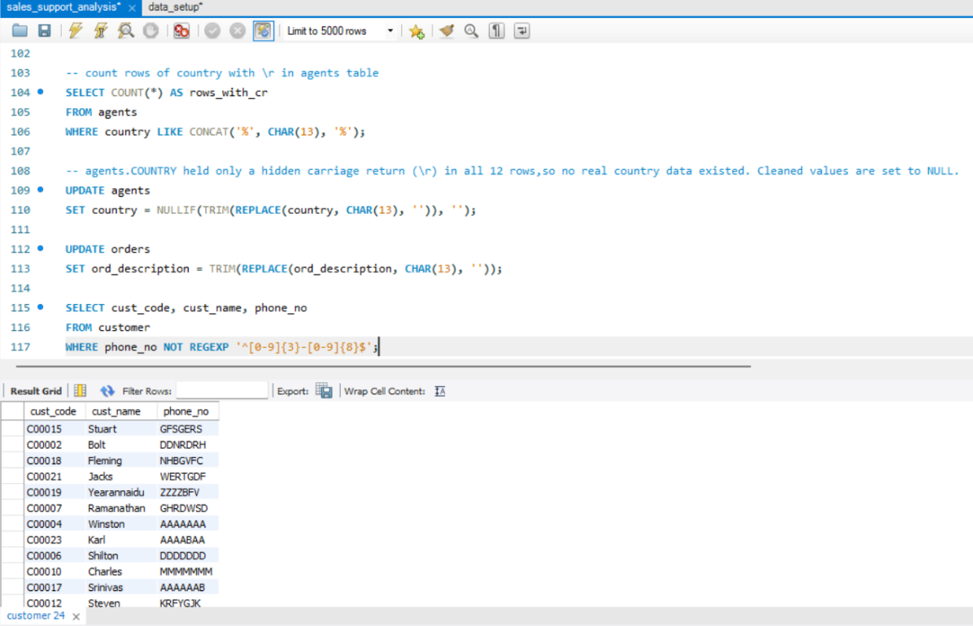

ALTER TABLE customer MODIFY phone_no VARCHAR(17) NULL;

UPDATE customer
SET phone_no = NULL
WHERE phone_no NOT REGEXP '^[0-9]{3}-[0-9]{8}$';

SET SQL_SAFE_UPDATES = 1;

SELECT 'orders.ord_description (CR)', COUNT(*)
FROM orders WHERE ord_description LIKE CONCAT('%', CHAR(13), '%');
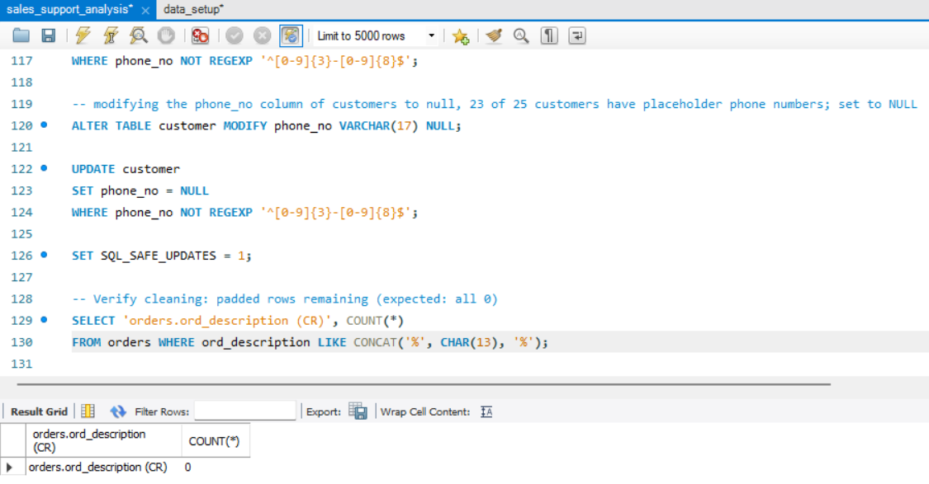
Output columns (in order): orphan_agent_code
Row count: 1 (A013)
Concept used: LEFT JOIN, IS NULL, DISTINCT
Table used: orders, agents

SELECT DISTINCT o.agent_code AS orphan_agent_code
FROM orders o
LEFT JOIN agents a ON o.agent_code = a.agent_code
WHERE a.agent_code IS NULL;

SELECT ord_num, cust_code, agent_code, ord_amount
FROM orders
WHERE agent_code = 'A013';

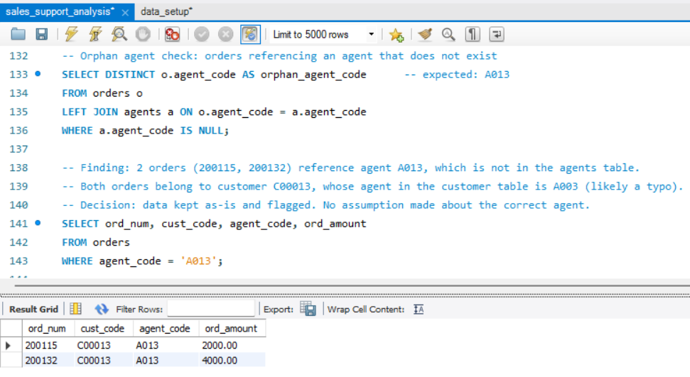

- Analyse the data types of the columns in each table to ensure they are appropriate for the stored data.

Output columns (in order): Field, Type, Null, Key, Default, Extra (DESCRIBE output)
Row count: orders 7, customer 12
Concept used: ALTER TABLE MODIFY (ORD_NUM to INT, GRADE to TINYINT)
Table used: orders, customer
Query:
ALTER TABLE orders MODIFY ord_num INT NOT NULL;

ALTER TABLE customer MODIFY grade TINYINT;

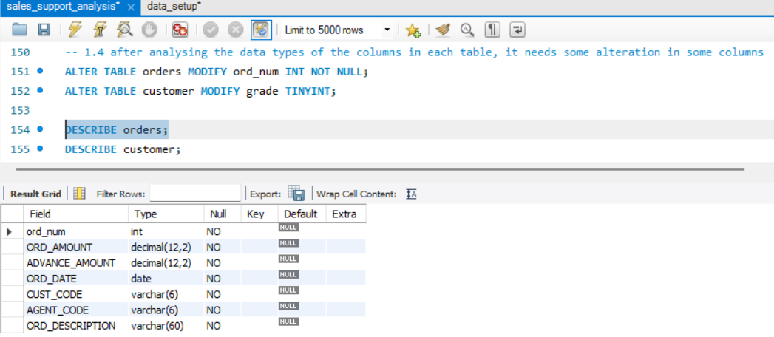

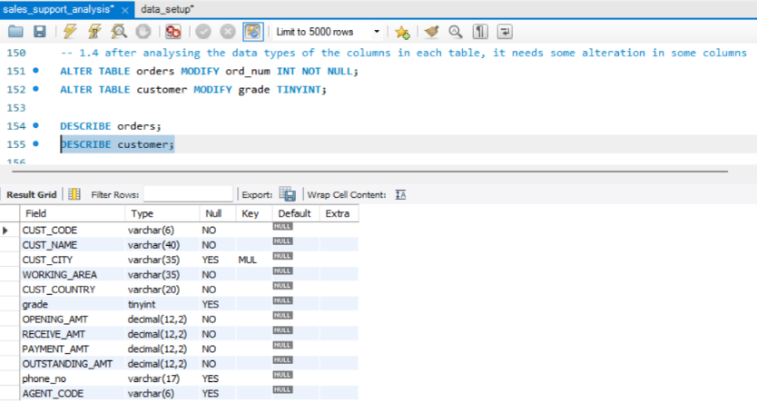

- Identify any duplicate records within the tables and develop a strategy for handling them.

Output columns (in order): cust_code / agent_code / ord_num, cnt
Row count: 0 in each query (no duplicates)
Concept used: GROUP BY, HAVING COUNT(*) > 1
Table used: customer, agents, orders
Query:
SELECT cust_code, COUNT(*) AS cnt
FROM customer
GROUP BY cust_code
HAVING COUNT(*) > 1;

SELECT agent_code, COUNT(*) AS cnt
FROM agents
GROUP BY agent_code
HAVING COUNT(*) > 1;

SELECT ord_num, COUNT(*) AS cnt
FROM orders
GROUP BY ord_num
HAVING COUNT(*) > 1;

SELECT cust_code, agent_code, ord_date, ord_amount, COUNT(*) AS cnt
FROM orders
GROUP BY cust_code, agent_code, ord_date, ord_amount
HAVING COUNT(*) > 1;

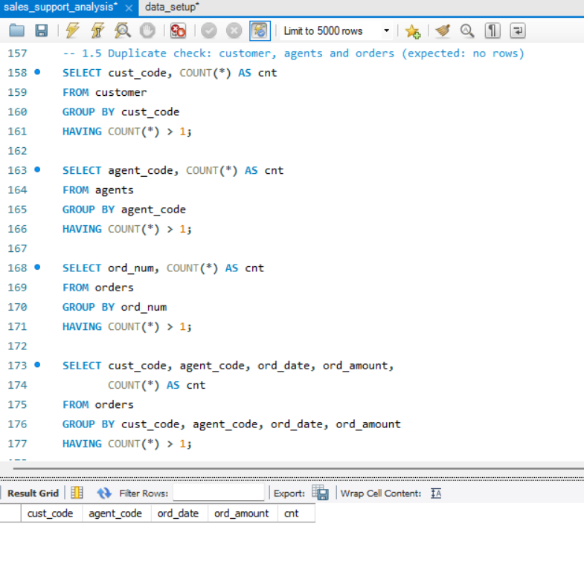No duplicates were found. If found, the strategy would be to keep one record per key using ROW_NUMBER() OVER (PARTITION BY key ORDER BY key) and delete rows where the row number is greater than 1.
Primary keys added to customer and orders, which had none.

ALTER TABLE customer ADD PRIMARY KEY (cust_code);

ALTER TABLE orders ADD PRIMARY KEY (ord_num);

Segment 2: Basic Sales Analysis
- Write SQL queries to retrieve the total number of orders, total revenue, and average order value.

Output columns (in order): total_orders, total_revenue, avg_order_value
Row count: 1 (36, 78600.00, 2183.33)
Concept used: COUNT, SUM, AVG, ROUND
Table used: orders
Query:
SELECT COUNT(*) AS total_orders,
SUM(ord_amount) AS total_revenue,
ROUND(AVG(ord_amount),2) AS avg_order_value
FROM orders;

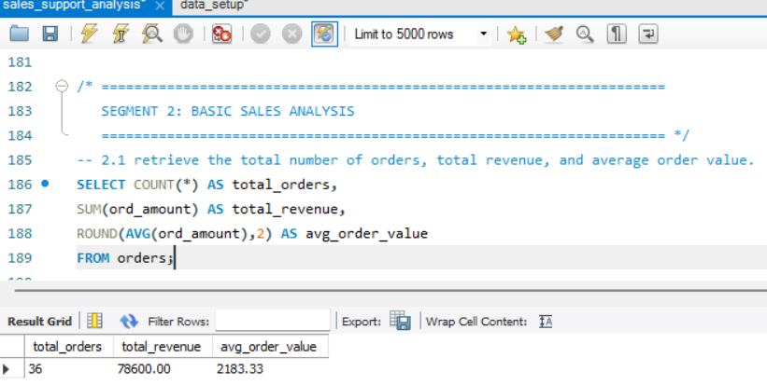
- The operations team needs to track the agent who has handled the maximum number of high-grade customers. Write a SQL query to find the agent_name who has the highest count of customers with a grade of 5. Display the agent_name and the count of high-grade customers.

Output columns (in order): agent_name, high_grade_customers
Row count: 0 (no customer has grade 5)
Concept used: JOIN, WHERE, GROUP BY, ORDER BY, LIMIT
Table used: agents, customer
Query:
SELECT a.agent_name, COUNT(*) AS high_grade_customers
FROM agents a
JOIN customer c
ON a.agent_code = c.agent_code
WHERE c.grade = 5
GROUP BY a.agent_code, a.agent_name
ORDER BY high_grade_customers DESC
LIMIT 1;

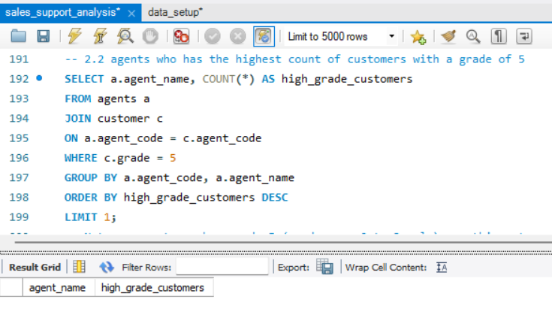
Agent with the most high grade customers with a concept of subquery.

SELECT a.agent_name, COUNT(*) AS high_grade_customers
FROM agents a
JOIN customer c
ON a.agent_code = c.agent_code
WHERE c.grade = (SELECT MAX(grade) FROM customer)
GROUP BY a.agent_code, a.agent_name
ORDER BY high_grade_customers DESC
LIMIT 1;

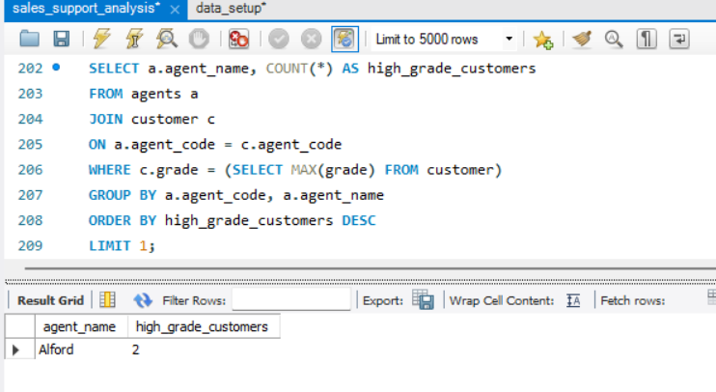
- The company wants to identify the most active customer cities in terms of the total order amount. Write a SQL query to find the top 3 customer cities with the highest total order amount. Include cust_city and total_order_amount in the output.

Output columns (in order): agent_name, high_grade_customers
Row count: 0 (no customer has grade 5)
Concept used: JOIN, WHERE, GROUP BY, ORDER BY, LIMIT
Table used: agents, customer
Query:
SELECT c.cust_city, SUM(o.ord_amount) AS total_order_amount
FROM customer c
JOIN orders o
ON c.cust_code = o.cust_code
GROUP BY c.cust_city
ORDER BY total_order_amount DESC
LIMIT 3;

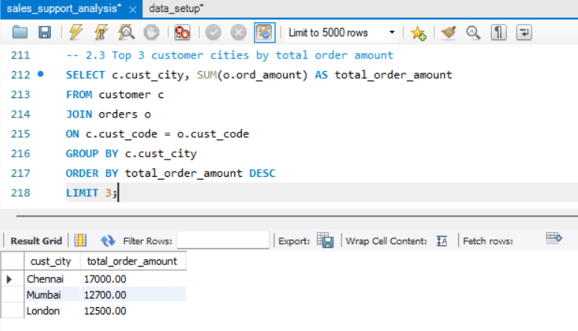

Segment 3: Customer Analysis:
- Calculate the total number of customers.

Output columns (in order): total_customers
Row count: 1 (25)
Concept used: COUNT(*)
Table used: customer
Query:
SELECT COUNT(*) AS total_customers FROM customer;
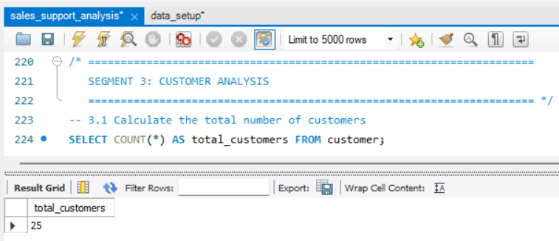

- Identify the top-spending customers based on their total order value.

Output columns (in order): cust_code, cust_name, total_spent, spend_rank
Row count: 6 (Ravindran and Avinash tie at 5000)
Concept used: JOIN, SUM, RANK() OVER, subquery
Table used: customer, orders
Query:
SELECT c.cust_code, c.cust_name, SUM(o.ord_amount) AS total_spent
FROM customer c
JOIN orders o
ON c.cust_code = o.cust_code
GROUP BY c.cust_code, c.cust_name
ORDER BY total_spent DESC
LIMIT 5;

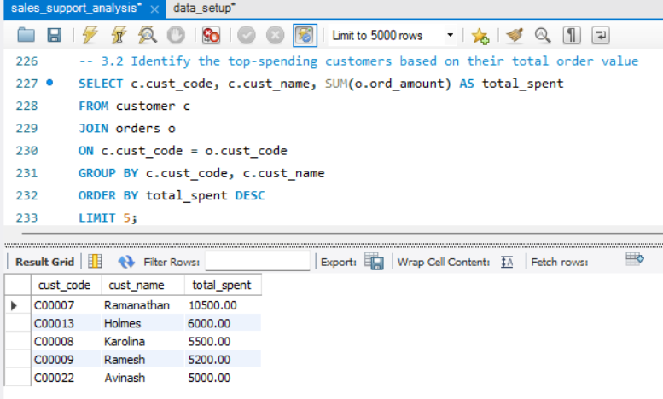
Now what if there will be any same total spent value of multiple customers, it will be a tie so to fix this we will use rank() window function
SELECT cust_code, cust_name, total_spent, spend_rank
FROM
(SELECT c.cust_code, c.cust_name, SUM(o.ord_amount) AS total_spent, RANK() OVER(ORDER BY SUM(o.ord_amount) DESC) AS spend_rank
FROM customer c
JOIN orders o
ON c.cust_code = o.cust_code
GROUP BY c.cust_code, c.cust_name) t
WHERE spend_rank <= 5
ORDER BY spend_rank, cust_name;
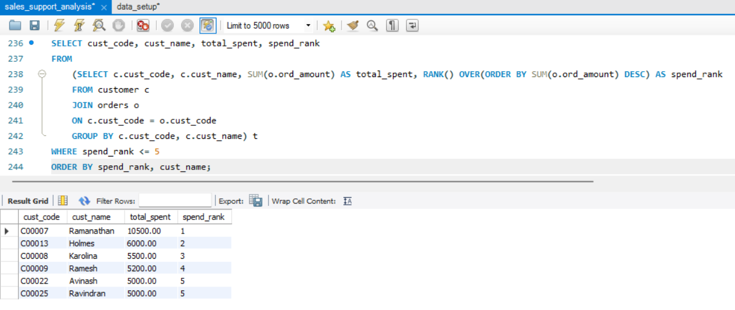
Ravindran and Avinash tie at 5000, so LIMIT 5 would drop one arbitrarily; RANK() keeps both

- Analyse customer retention by calculating the percentage of repeat customers.

Output columns (in order): total_customers, repeat_customers, repeat_customer_pct
Row count: 1 (25, 8, 32.00)
Concept used: subquery, SUM of true/false, ROUND
Table used: orders
Query:
SELECT COUNT(*) AS total_customers,
SUM(order_count > 1) AS repeat_customers,
ROUND(SUM(order_count > 1)/ COUNT(*) * 100,2) AS repeat_cust_percentage
FROM (
SELECT cust_code, COUNT(*) AS order_count
FROM orders
GROUP BY cust_code) t;

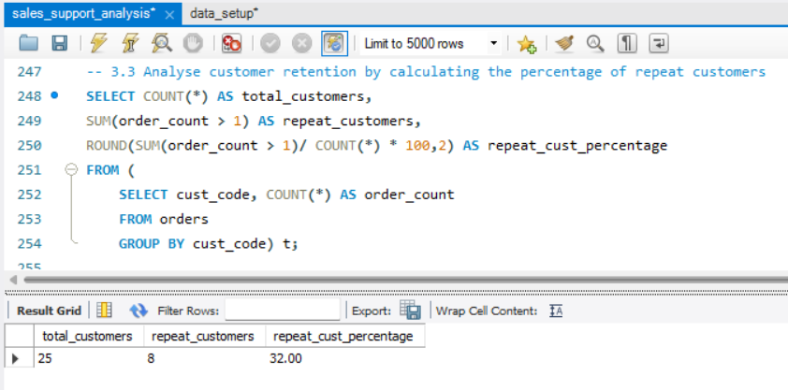

- Find the name of the customer who has the maximum outstanding amount from every country.

Output columns (in order): cust_name, cust_country, outstanding_amt
Row count: 8 (India has 3 tied, USA has 2 tied)
Concept used: RANK() OVER (PARTITION BY), subquery
Table used: customer
Query:

SELECT cust_name, cust_country, outstanding_amt
FROM(
SELECT cust_name, cust_country, outstanding_amt, RANK() OVER(PARTITION BY cust_country ORDER BY outstanding_amt DESC) AS rnk
FROM customer) t
WHERE rnk = 1
ORDER BY cust_country, cust_name;

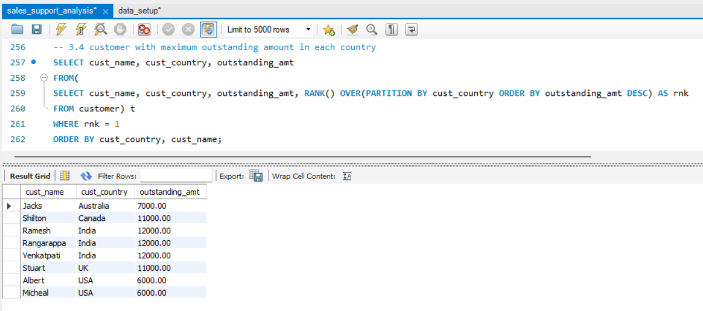

- Write a SQL query to calculate the percentage of customers in each grade category (1 to 5).

Output columns (in order): grade, customers, pct_of_customers
Row count: 3 (grades 1 to 3: 36%, 40%, 20%)
Concept used: COUNT, scalar subquery, BETWEEN, ROUND
Table used: customer

The grades are only from 0 to 3 in the table, it will not show grade 4 and 5
Query:
SELECT grade, COUNT(*) AS customers, ROUND(100 * COUNT(*) / (SELECT COUNT(*) FROM customer), 2) AS pct_of_customers
FROM customer
WHERE grade BETWEEN 1 AND 5
GROUP BY grade
ORDER BY grade;

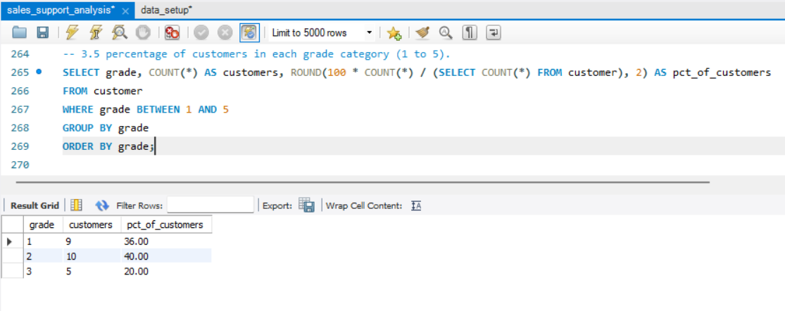
So to show the grades from 1 to 5 with customer percentage we will use recursive cte which will create a list from 1 to 5 and the the percentage for grade 4 and 5 will show 0%.

Output columns (in order): grade, customers, pct_of_customers
Row count: 5 (grades 4 and 5 show 0)
Concept used: recursive CTE, LEFT JOIN, COUNT(column)
Table used: customer
Query:
WITH RECURSIVE grades AS (
SELECT 1 AS grade
UNION ALL
SELECT grade + 1 FROM grades WHERE grade < 5
)
SELECT g.grade, COUNT(c.cust_code) AS customers, ROUND(100 * COUNT(c.cust_code) / (SELECT COUNT(*) FROM customer), 2) AS pct_of_customers
FROM grades g
LEFT JOIN customer c
ON c.grade = g.grade
GROUP BY g.grade
ORDER BY g.grade;

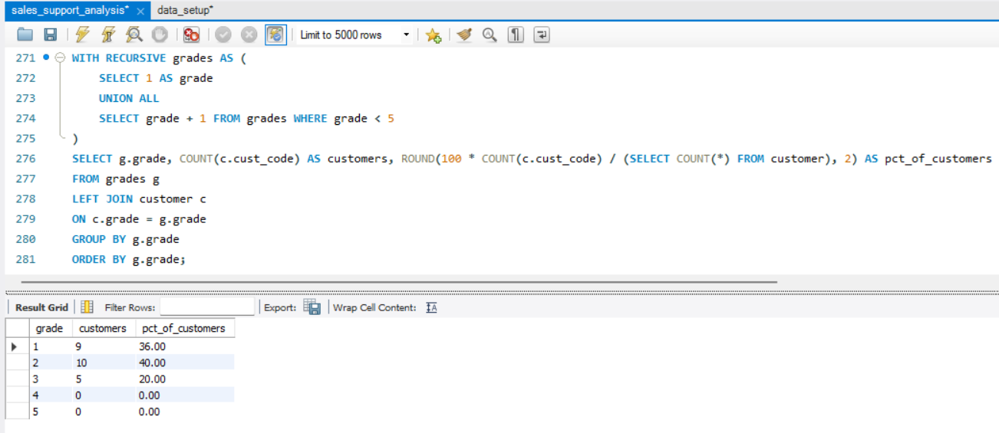

Segment 4: Agent Performance Analysis
- Company wants to provide a performance bonus to their best agents based on the maximum order amount. Find the top 5 agents eligible for it.

Output columns (in order): agent_code, agent_name, total_order_amount, amount_rank Row count: 5 (no tie in the current data)
Concept used: JOIN, SUM, RANK() OVER, subquery
Table used: agents, orders
Query:
SELECT agent_code, agent_name, total_order_amount, amount_rank
FROM (
SELECT a.agent_code, a.agent_name, SUM(o.ord_amount) AS total_order_amount, RANK() OVER (ORDER BY SUM(o.ord_amount) DESC) AS amount_rank
FROM agents a
JOIN orders o
ON a.agent_code = o.agent_code
GROUP BY a.agent_code, a.agent_name
) t
WHERE amount_rank <= 5
ORDER BY amount_rank, agent_name;

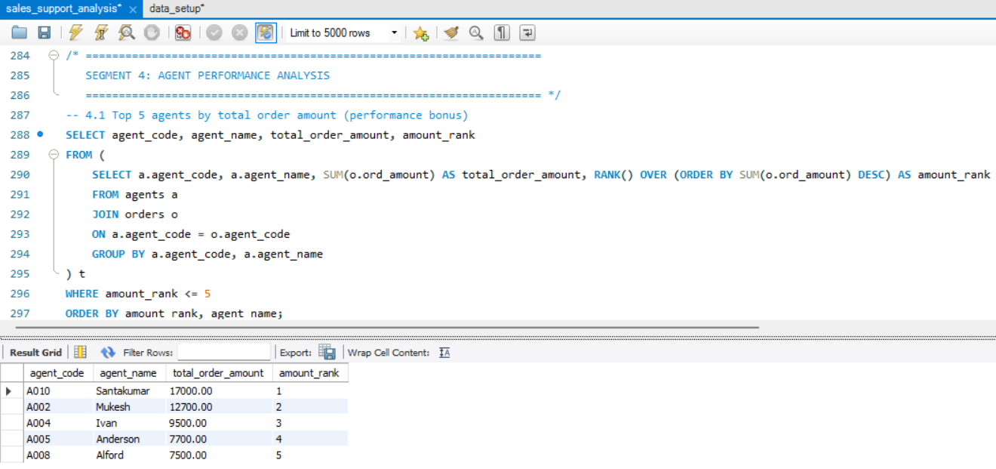

- The company wants to analyse the performance of agents based on the number of orders they have handled. Write a SQL query to rank agents based on the total number of orders they have processed. Display agent_name, total_orders, and their respective ranking.

Output columns (in order): agent_name, total_orders, order_rank
Row count: 12 (DENSE_RANK gives ranks 1 to 6)
Concept used: LEFT JOIN, COUNT(column), DENSE_RANK() OVER
Table used: agents, orders

Query:
SELECT agent_code, agent_name, total_order_count, order_rank
FROM (
SELECT a.agent_code, a.agent_name, COUNT(o.ord_num) AS total_order_count, DENSE_RANK() OVER (ORDER BY COUNT(o.ord_num) DESC) AS order_rank
FROM agents a
LEFT JOIN orders o
ON a.agent_code = o.agent_code
GROUP BY a.agent_code, a.agent_name
) t
ORDER BY order_rank, agent_name;

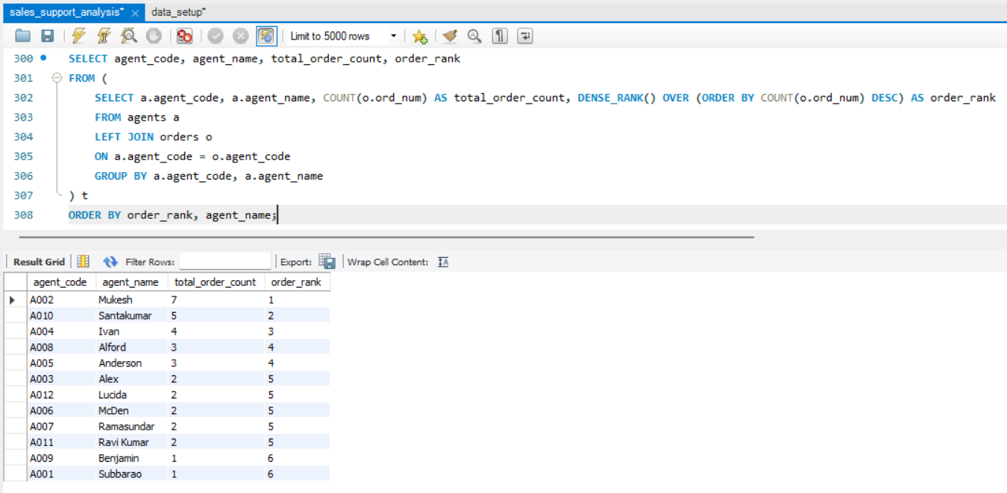

- Company wants to change the commission for the agents, basis advance payment they collected. Write a sql query which creates a new column updated_commision on the basis below rules.
  - If the average advance amount collected is less than 750, there is no change in commission.
  - If the average advance amount collected is between 750 and 1000 (inclusive), the new commission will be 1.5 times the old commission.
  - If the average advance amount collected is more than 1000, the new commission will be 2 times the old commission.

Output columns (in order): agent_code, agent_name, old_commission, avg_advance_amount, updated_commision
Row count: 12 (only Anderson and Alford change)
Concept used: LEFT JOIN, AVG, CASE, ROUND
Table used: agents, orders

Query:
SELECT a.agent_code, a.agent_name, a.commission AS old_commission, ROUND(AVG(o.advance_amount), 2) AS avg_advance_amount,
ROUND(
CASE
WHEN AVG(o.advance_amount) > 1000 THEN a.commission * 2
WHEN AVG(o.advance_amount) >= 750 THEN a.commission * 1.5
ELSE a.commission
END, 2) AS updated_commision
FROM agents a
LEFT JOIN orders o
ON a.agent_code = o.agent_code
GROUP BY a.agent_code, a.agent_name, a.commission
ORDER BY a.agent_code;

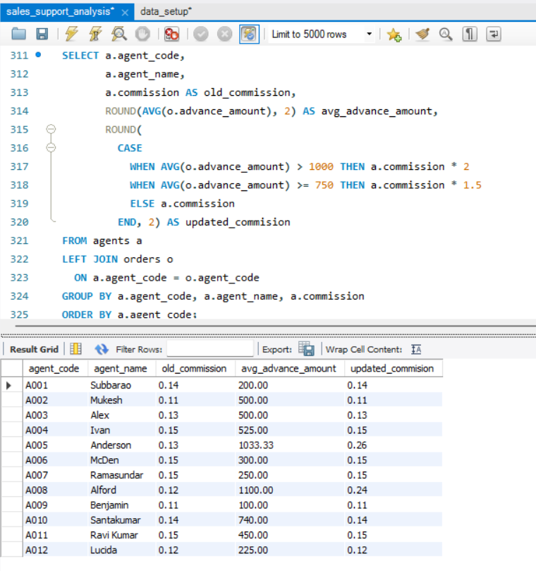
Segment 5: SQL Tasks
- Add a new column named avg_rcv_amt in the table customers which contains the average receive amount for every country. Display all columns from the customer table along with the avg_rcv_amt column in the last.

Output columns (in order): none Row count: n/a
Concept used: ALTER TABLE ADD COLUMN
Table used: customer
Query:
ALTER TABLE customer ADD COLUMN avg_rcv_amt DECIMAL(12,2);

Output columns (in order): cust_country, avg_rcv
Row count: 5
Concept used: AVG, GROUP BY, ROUND
Table used: customer

Query:
SELECT cust_country, ROUND(AVG(receive_amt), 2) AS avg_rcv
FROM customer
GROUP BY cust_country
ORDER BY cust_country;

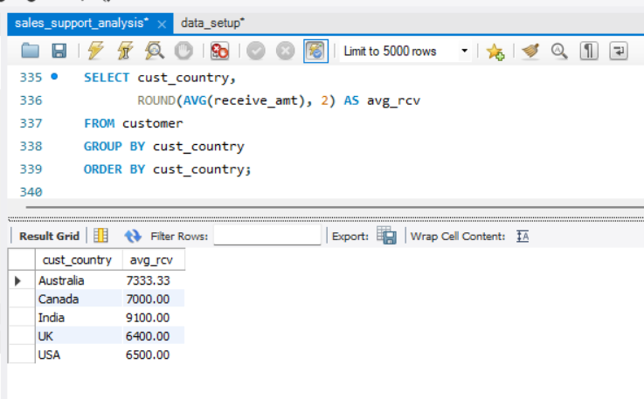

Output columns (in order): none
Row count: 25 rows affected
Concept used: UPDATE with JOIN on a derived table
Table used: customer

Query:
UPDATE customer c
JOIN (SELECT cust_country,
ROUND(AVG(receive_amt), 2) AS avg_rcv
FROM customer
GROUP BY cust_country) x
ON c.cust_country = x.cust_country
SET c.avg_rcv_amt = x.avg_rcv;

Output columns (in order): all 13 customer columns, with avg_rcv_amt last
Row count: 25
Concept used: SELECT *
Table used: customer

Query:
SELECT * FROM customer;

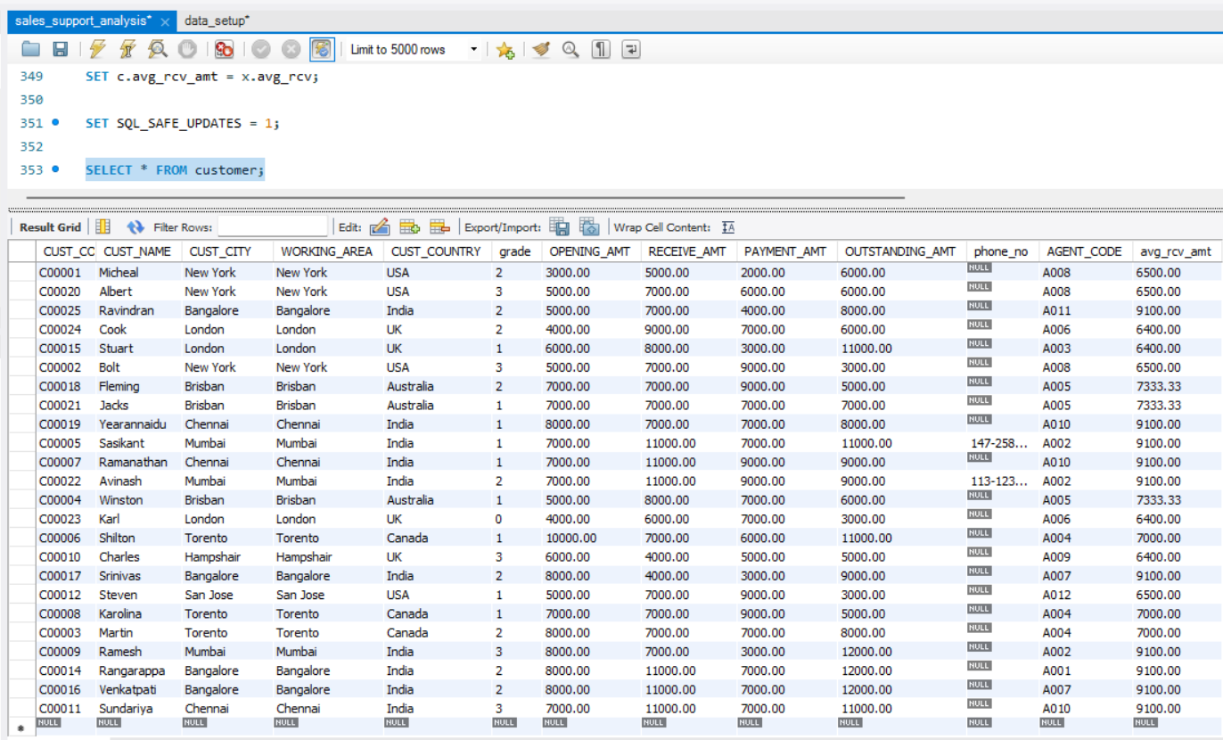

- Write a sql query to create and call a UDF named avg_amt to return the average outstanding amount of the customers which are managed by a given agent. Also, call the UDF with the agent name ‘Mukesh’.

Output columns (in order): avg_outstanding_amt
Row count: 1 (10666.67)
Concept used: CREATE FUNCTION, parameter, DECLARE, SELECT INTO, RETURN Table used: customer, agents

Query:
DELIMITER $$
CREATE FUNCTION avg_amt (p_agent_name VARCHAR(40))
RETURNS DECIMAL(12,2)
READS SQL DATA
BEGIN
DECLARE v_avg DECIMAL(12,2);

SELECT AVG(c.outstanding_amt)
INTO v_avg
FROM customer c
JOIN agents a
ON c.agent_code = a.agent_code
WHERE a.agent_name = p_agent_name;

RETURN v_avg;
END$$
DELIMITER ;

Now calling the function for “Muskesh”

SELECT avg_amt('Mukesh') AS avg_outstanding_amt;

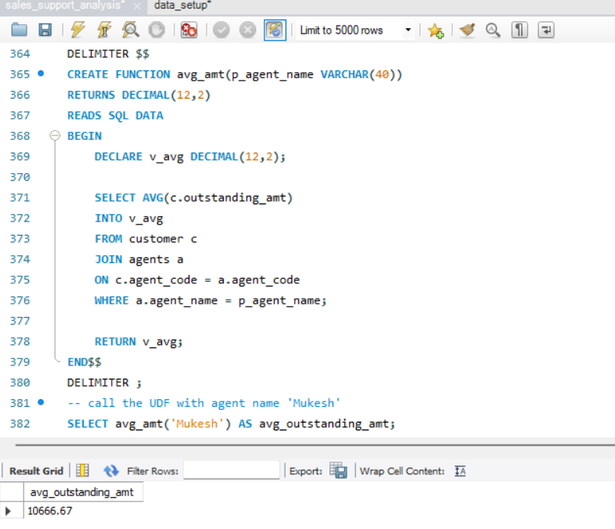
- Write a sql query to create and call a subroutine called cust_detail to return all the details of the customer which are having the given grade. Also, call the subroutine with grade 2.

Output columns (in order): all 13 customer columns
Row count: 10 (grade 3 gives 5 rows, grade 5 gives 0)
Concept used: CREATE PROCEDURE, IN parameter, DELIMITER
Table used: customer

Query:
DELIMITER $$
CREATE PROCEDURE cust_detail(IN p_grade INT)
BEGIN
SELECT *
FROM customer
WHERE grade = p_grade;
END$$
DELIMITER ;

Calling for grade 2
CALL cust_detail(2);

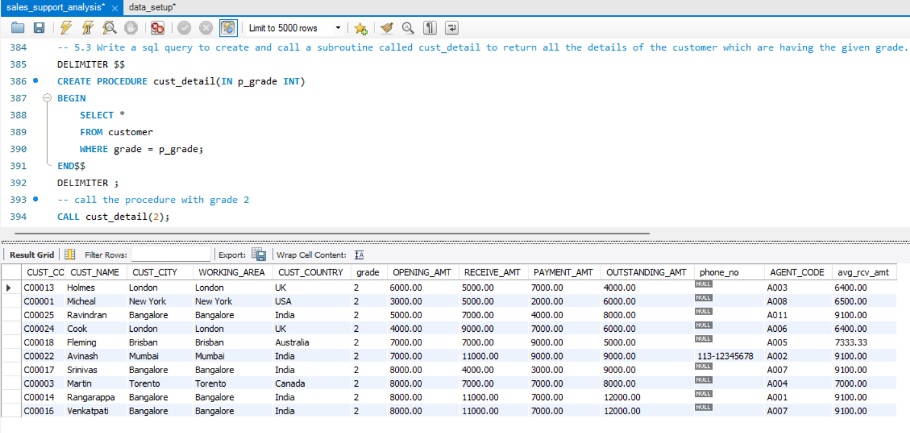
- Write a stored procedure sp_name which will return the concatenated ord_num (comma separated) of the customer with input customer code using cursor. Also, write the procedure call query with cust_code ‘C00015’.

Output columns (in order): cust_code, ord_nums
Row count: 1 (200100,200127)
Concept used: CURSOR, CONTINUE HANDLER, LOOP, CONCAT
Table used: orders
Query:
DELIMITER $$
CREATE PROCEDURE sp_name(IN p_cust_code VARCHAR(6))
BEGIN
DECLARE v_ord_num VARCHAR(10);
DECLARE v_result TEXT DEFAULT '';
DECLARE v_done INT DEFAULT 0;

DECLARE cur_orders CURSOR FOR
SELECT ORD_NUM
FROM orders
WHERE CUST_CODE = p_cust_code
ORDER BY ORD_NUM;

DECLARE CONTINUE HANDLER FOR NOT FOUND SET v_done = 1;

OPEN cur_orders;

read_loop: LOOP
FETCH cur_orders INTO v_ord_num;
IF v_done = 1 THEN
LEAVE read_loop;
END IF;

IF v_result = '' THEN
SET v_result = v_ord_num;
ELSE
SET v_result = CONCAT(v_result, ',', v_ord_num);
END IF;
END LOOP;

CLOSE cur_orders;

SELECT v_result AS ord_numbers;
END$$
DELIMITER ;
Calling the customer whose cust_code is ‘C00015’

CALL sp_name('C00015');

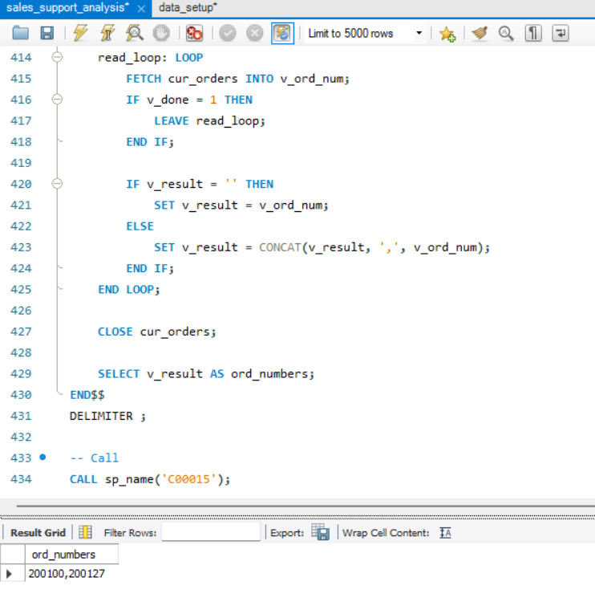

Evaluation pointers:
- The tasks are correctly identified and executed.
- The solution output matches the expected output.
- The query is optimised and syntactically correct.
- Proper aliases are used
- If required any, appropriate comments are written.
- The code is written concisely with appropriate indentations.

